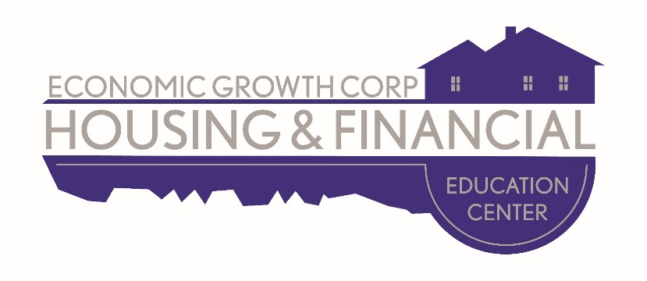

Homebuyer Class Schedule 2018
The class is held once per month on a Saturday from 8:30 a.m.- 4:00 p.m. at the
Economic Growth Corporation conference room located inside McKesson Lofts at
100 19th Street, Rock Island, IL.

Class is from 8:30 a.m. until 4:00 p.m.

A pizza lunch will be provided.

For reservations, call 309-788-6311.

All classes are on Saturday:
January 20, 2018
February 17, 2018
March 10, 2018
April 14, 2018
May 19, 2018
June 16, 2018
July 14, 2018
August 11, 2018
September 15, 2018
October 13, 2018
November 17, 2018
No class in December

