For more information contact:
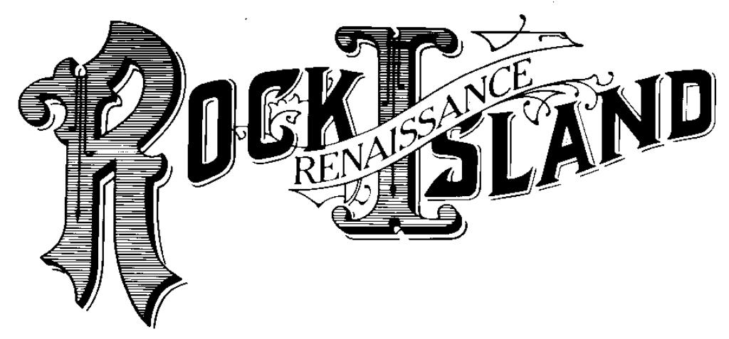

Brian Hollenback
President
Renaissance Rock Island
100 19th Street, Suite 109
Rock Island, IL 61201
(309) 788-6311
brian@teamrockisland.com

Embargoed until Tuesday, Feb 3, 2015

FOR IMMEDIATE RELEASE – 4/7/2016

Renaissance Rock Island receives National James Leach Award from National Community Reinvestment Coalition

ROCK ISLAND, IL -- National Community Reinvestment Coalition’s (NCRC) awarded Renaissance Rock Island the “Representative James Leach” award on March 17, 2016 at NCRC’s Annual Conference in Washington, D.C. The national award recognizes the most outstanding rural non-profit organization in the country that best promotes fair and equal access to credit and capital and/or contributes the most in its community toward promoting wealth building in traditionally underserved populations.

“As a community based development organization, we look to fill the needs of a community. We continue to look for every housing resource and leverage as much as we can in order to fulfill community needs. Being a part of NCRC has helped us become who we are today, by providing their resources and advocacy as a way to increase opportunities for community impact in underserved areas generating business growth, economic development, and job creation,” said Renaissance Rock Island President Brian Hollenback.

Established over 30 years ago, Renaissance Rock Island is an umbrella name for interconnected organizations that work to advance revitalization efforts in Rock Island, IL. Through Renaissance Rock Island’s efforts, more than $281 Million has been deployed into urban core redevelopment projects, resulting in the creation of over 3500 jobs, impacting over 1150 single family units, creating 228 units of multi-family housing, welcoming nearly 700 homebuyers, and generating over $233 Million in economic impact.

In 1999, GROWTH, was designated as a Community Housing Development Organization (CHDO) by the U.S. Department of Housing and Urban Development (HUD). CHDOs qualify for a special set aside for funding, technical assistance and pre-development dollars. In 2003, Renaissance Rock Island was approved by HUD as a Local Housing Counseling Agency. These actions have allowed Renaissance Rock Island to serve diverse populations in homebuyer education, foreclosure prevention, home maintenance, mortgages, credit, and more.

GROWTH became a national community based development organization in 2012 under the name of “Economic Growth Corporation.” Since becoming a national entity, over $65.4 million in housing and economic development resources have been invested in northwestern Illinois through the Neighborhood Stabilization Program 1 & 2 and Illinois Attorney General National Foreclosure Settlement Grant Funds. These resources have been invested in rural communities.

Specifically, GROWTH was awarded $3.5 M in Illinois Attorney General National Foreclosure Settlement Funds in 2014. To date, over $3 million or 89% of the total grant award has been leveraged with an additional $21.4 Million in public and private resources for a total of nearly $25 Million deployed into rural areas to advance efforts that include new rental construction, new single family homeownership, homebuyer and financial education counseling and demolition activities.

GROWTH it also has pioneered the creation of the first Employer Assisted Housing Program in the state of Illinois known as Live-Work Rock Island. Now in Phase 8, the program has welcomed nearly 300 homebuyers to Rock Island, generating nearly $27 million in real estate transactions with 52% relocating from outside communities. It currently is asking letters of support for Phase 9 of the Program, which aims to assist up to 60 homebuyers purchase homes in Rock Island.

It also runs a successful financial education program that has assisted nearly 2,300 homebuyers and homeowners purchase homes or save them from foreclosure. GROWTH’s homebuyer education class draws potential homebuyers in from a 150-mile radius to receive HUD-approved, Freddie-Mac certified financial education to purchase homes through various homebuyer programs. As GROWTH continues to grow in its footprint, it has incorporated the ability for homebuyers to Skype into its homebuyer education courses, so to further its impact in creating homeownership opportunities to those wishing to purchase a home in Rock Island, the Illinois-Quad Cities, and beyond.

Additional services provided through Renaissance Rock Island include incubating micro businesses, supporting downtown Rock Island’s hospitality zone through the creation of signature festivals, and running its own general contracting company for smaller mixed-use and housing development projects.

Renaissance Rock Island supports 140 local jobs operating small businesses within its downtown commercial properties, and has attracted over 2.5 million visitors through nationally- recognized signature events.

Looking ahead to the next 30 years, Renaissance Rock Island looks forward to furthering its impact on a local, regional, and national level that help advance the creation, growth, and expansion of business, investment, and jobs into underserved communities.

About Renaissance Rock Island
Renaissance Rock Island is a consortium four companies, which include a national non-profit and national for-profit, that work together for the benefit of low income communities and persons—all with missions focused on increasing opportunities for community impact in Rock Island and underserved areas generating business growth, economic development, and job creation.
- Rock Island Economic Growth Corporation, or GROWTH, was formulated in 1982 with a mission to enhance the overall image and economic vitality of Rock Island by improving housing market dynamics, encouraging home ownership, creating jobs, and growing the tax base. GROWTH, a 501c3 not-for-profit Community Housing Development Organization, serves as the cornerstone organization of Renaissance Rock Island. In 2012, GROWTH Board voted to become a national non-profit community development organization, using a unified regional approach identifying new partnerships and new opportunities to bring national resources to the region.
- Development Association of Rock Island, or DARI, was formulated in 1986 with a mission to promote commercial, industrial and recreational development through ownership or management of businesses or properties, or by providing business assistance to enhance the local tax base and quality of life in Rock Island.
- The Downtown Rock Island Arts & Entertainment District, or The District, Inc., was formulated in 1992 with a mission to market the downtown and produce unique events.

About NCRC
National Community Reinvestment Coalition (NCRC) was formed in 1990 by national, regional, and local organizations to develop and harness the collective energies of community reinvestment organizations from across the country so as to increase the flow of private capital into traditionally underserved communities. NCRC has grown to an association of more than 600 community-based organizations that promote access to basic banking services, including credit and savings, to create and sustain affordable housing, job development and vibrant communities for America’s working families.

###

